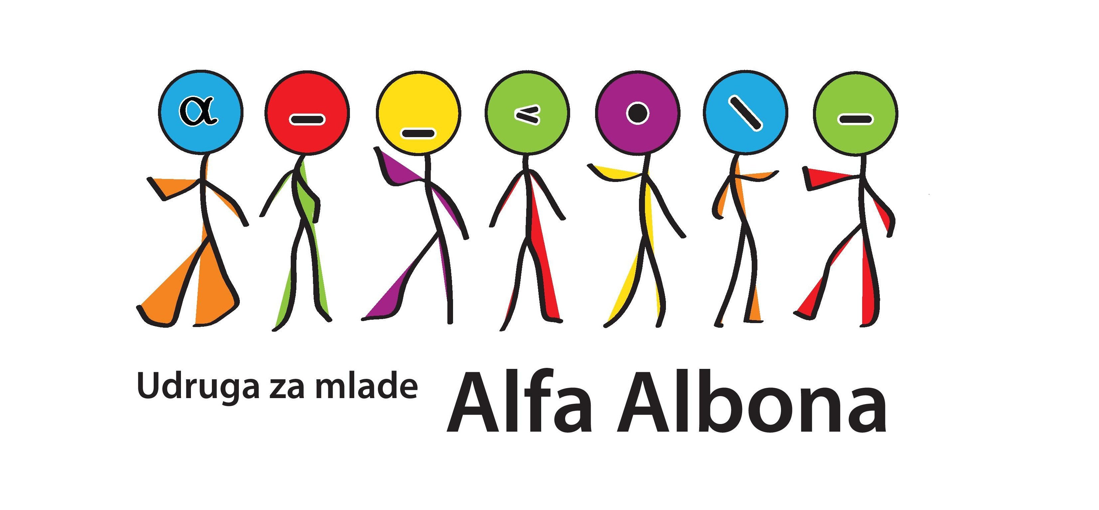
YOUTH EXCHANGE:
»EXPLORE AND DISCOVER«
LABIN, CROATIA 02. – 08.06.2014.

- APPLICATION FORM -
Name and surname:
Date of birth:
Address:
Cellphone number:
E-mail:
Occupation:
Level of english language:
Are you familiar with the programme Youth in Action and have you ever participated on some project or activitiy within the programme?
Describe shortly and clearly your motivation and experience in the area of art.
What would be your personal aims and expectations for this training? What would you want to learn/gain from this experience?
Specify any food requirements that you have (vegetarian, allergies, etc) and any requirements that you have (mobility, medical condition, religious, etc). Otherwise leave blank.

Application form please send till 20.05.2014. to alfa.albona@gmail.com with subject »Explore and discover«.

Hope to see you in Labin! :)

